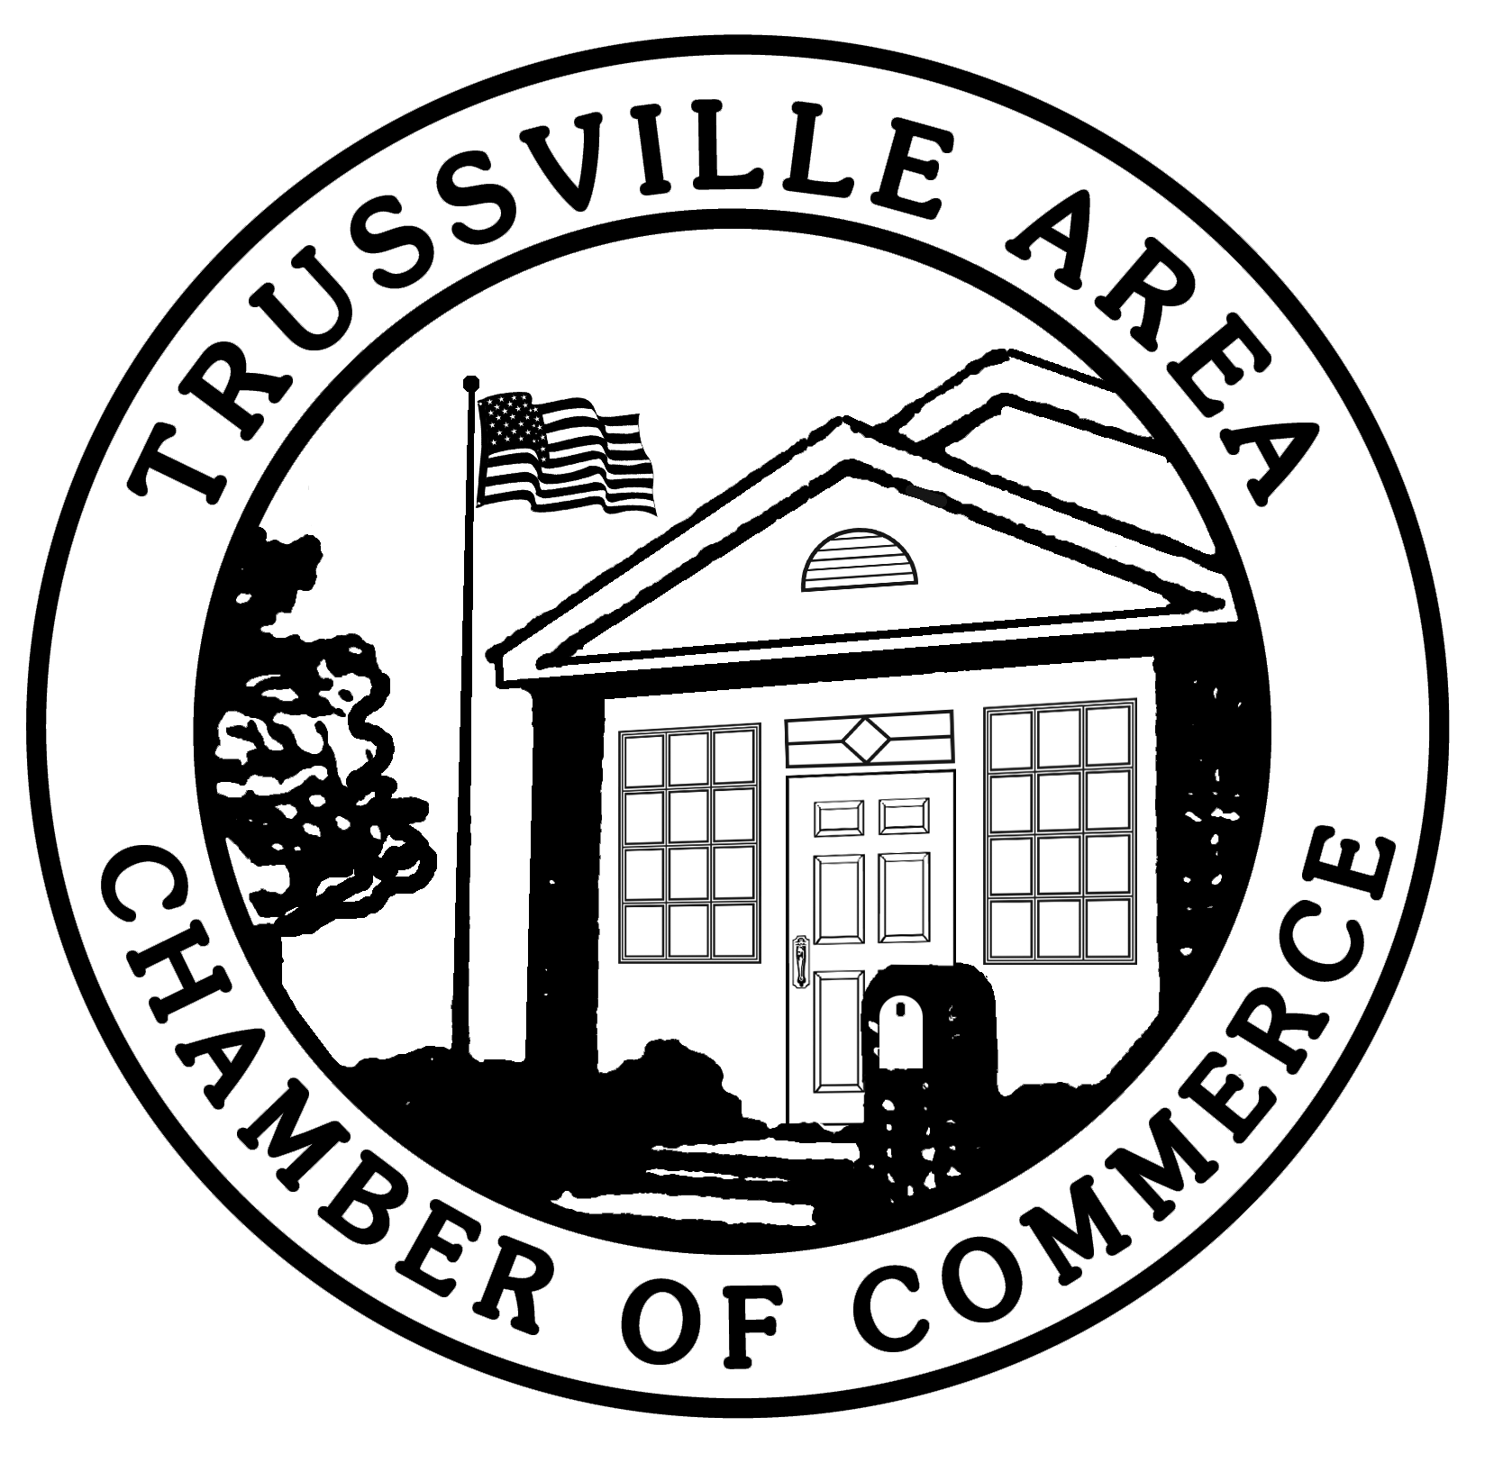
2019 Ambassador Application Packet
Assisting the Chamber in Recruiting and Retaining Members
and Coordinating Events

Mission: To assist the Chamber in recruiting and retaining members and coordinating events.

Objectives:
- Educate members about the services and benefits of their membership.
- Foster new member engagement in chamber programs and events.
- Nurture quality relationships.
- Assist chamber staff in coordination of events.

Meeting Time: Second Tuesday of the month, 8:30 a.m., at the chamber office (400 Main St.).

Term of service: One calendar year. A new application must be submitted each year.

Benefits to Ambassadors:
- Listing on the ambassador page of the chamber’s website (www.trussvillechamber.com)
- Introduction in an article in the chamber’s e-newsletter
- Opportunity to be recognized as Ambassador of the Year and featured in the chamber’s e-newsletter
- Official Ambassador Name Badge

Requirements:
- Attend monthly meetings. The meetings are held at the chamber office.
- Assist with at least two (2) of the chamber’s major events plus City Fest. Major events include the annual banquet, golf tournament, Maple Leaf Run, TASTE (Trussville’s Art Show and Tasting Event), the leadership conference, and Trussville’s Christmas parade.
- Assist with other events as possible. The chamber presents monthly luncheons, occasional breakfasts, Business After Hours events, ribbon cuttings, and more.
- Recruit at least two (2) new members per year. Ambassadors will keep membership brochures with them to distribute to potential new members as appropriate.
- Wear your name tag. Ambassadors are encouraged to wear their name tags at all chamber events.
- Chamber membership. Ambassadors must be an employee of a member company, an associate of a member company or an individual member of the chamber.

Ambassador Selection Process:
Ambassadors are selected through an application process. Applicants are evaluated on application info, professionalism, and chamber involvement.
Application for Ambassador Program

Name: _______________________________________________

Company Name: _______________________________________________

Position: _______________________________________________

Business Address: _______________________________________________

City, State, Zip: _______________________________________________

Work Phone: _______________________________________________

Cell Phone: _______________________________________________

E-Mail: _______________________________________________

Website: _______________________________________________

General Questions

- Did someone recommend you to become an Ambassador? If so, who? If no, please list one reference. ______________________________________________________________

- How long have you worked for your current employer? __________________________

- What is your impression of the TACC and the services it offers?
_______________________________________________________________________
_______________________________________________________________________
_______________________________________________________________________

- Which TACC events & activities have you attended in the past year? (Please mark all that apply.)

Annual Banquet _____
City Fest _____
Golf tournament _____
Maple Leaf Run _____
Christmas parade _____
Monthly luncheon _____
Business After Hours _____
Breakfast _____
Job Fair _____

Grand opening/
ribbon cutting _____
Taste of Trussville _____
Other (please list) __________________________________________________

- List any benefits your company has received from its TACC membership.
_________________________________________________________
_________________________________________________________
_________________________________________________________
Ambassador Questions

- Why do you want to be a TACC Ambassador?
_________________________________________________________
_________________________________________________________
_________________________________________________________

- What do you hope to gain from the experience?
_________________________________________________________
_________________________________________________________
_________________________________________________________

- Rank from 1-3 your priorities/interest in:
_____ Networking
_____ Identifying potential new member businesses
_____ Helping retain current member businesses

- What do you hope to bring to the Ambassador program?
_________________________________________________________
_________________________________________________________
_________________________________________________________

- Give an example of a volunteer experience you’ve had that has prepared you to effectively carry out the responsibilities of a TACC Ambassador.
_________________________________________________________
_________________________________________________________
_________________________________________________________

Ambassador Code of Conduct

Code of Conduct: All representatives of the Trussville Area Chamber of Commerce, as advocates for the community, will provide an inviting and open atmosphere for networking and conducting business. As public relations representatives for the Chamber, Ambassadors must demonstrate respect for the community, other businesses, and each other. The purpose of this document is to acknowledge the standards and measures of conduct to which Ambassadors will be held – by the Chamber and by each other.

Ambassador Conduct: As a member of the Ambassador Program, I recognize that membership is a privilege. Furthermore, membership brings with it the responsibility to ensure that all members also understand and commit to the membership standards and guidelines. Accordingly, I commit to:
1. Conduct all business and professional activities in a reputable manner, to reflect honorably upon myself and my business, to respect the good reputation of the Chamber, and represent the Chamber accordingly;
2. Understand, support, and promote the missions and goals of the Chamber;
3. Refrain from making sexual or other inappropriate comments, jokes or innuendo;
5. Respect the persons with whom I interact by honoring boundaries, recognizing there are different opinions, understandings and comfort levels, and accepting that it is possible to agree to disagree;
6. Respect the property, personal and professional, of the people and businesses with which I interact, by never stealing or defacing public or private property;
7. Participate, whenever reasonably possible, in the functions and activities of the Chamber, promoting business growth and related activities in the Trussville area.

I also understand that failure to adhere to the professional and personal obligations outlined above, and further defined in the Chamber by-Laws, can result in the termination of my membership in the Ambassador Program.

Ambassador Applicant Signature ______________________________________

Ambassador Applicant (please print) ______________________________________

Date ______________________________________

Agreement. Please initial next to the following items that you have read, understand and agree with the following expectations of being an Ambassador:
_______ I will carry out the mission of the Ambassadors and represent the Trussville Area Chamber of Commerce (TACC) in a professional manner, including abiding by a “business casual” or nicer dress code when serving as Ambassador (no shorts, jeans, sandals, Hawaiian shirts, etc., unless appropriate for a particular event).
_______ I am committed to growing the membership of TACC through membership prospect referrals.
_______ I will be informed about the events, activities and work of TACC in the area and work to engage new members into the offerings of the Chamber.
_______ I will ensure that my company remains in good standing with TACC.
_______ I will meet the required attendance at monthly Ambassador meetings.
_______ I will attend as many grand openings, ribbon cuttings, and other events as possible.
_______ I understand that failure to meet the attendance, duty, conduct or professional expectations of the program may result in dismissal from the Ambassador Program.
_______ My workplace is aware of my possible involvement as an Ambassador and supports the necessary commitment of time.

Signature
By submitting this application, I affirm that the facts set forth in it are true and complete. I also affirm that I am willing and able to make the time commitment required.

Printed Name: _____________________________________

Signature: _____________________________________

Date: _____________________________________

TACC provides equal opportunities without regard to race, color, religion, nationality, gender, sexual preference, age or disability.

Thank you for completing this application form and for your interest in volunteering with the Trussville Area Chamber of Commerce. You will be contacted in the next 30 days regarding your application to serve as an Ambassador.

